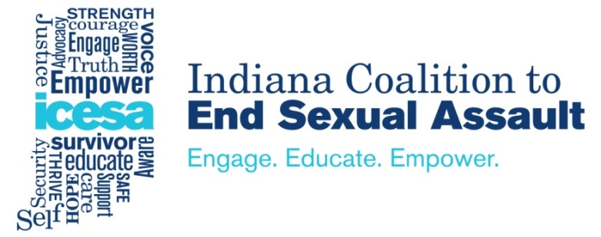
Application for Participation in ICESA Campus Consortium

- Name of Person Submitting Application

- Job Title of Person Submitting Application

- IHE’s geographic location in Indiana

- Brief description of IHE (private/public; number of undergrad and grad students; residential/commuter; urban/small town; etc.)

- Why is your IHE interested in joining the ICESA Campus Consortium? (250 word maximum)

- Describe your IHE’s institutional commitment to best practices in sexual violence prevention and response. Even if your IHE does not have a long history of institutional commitment, we would like to learn about your current administration’s interest in best practices. (250 word maximum)

- Provide a brief description of your campus sexual violence prevention efforts. These efforts may include special events, ongoing programs, student and employee trainings, etc. (250 word maximum)

- Does your campus already have a comprehensive, campus-wide task force, committee, or group that focuses on sexual violence prevention efforts? If so, please explain the structure, function, and goals of this group. (250 word maximum)

- Provide a brief description of your campus sexual violence response efforts. (250 word maximum)

- Does your campus already have a Sexual Assault Response Team (SART)? If so, please explain the structure, function, and goals of the SART, and if the SART is based on the Montclair State University model. (250 word maximum)

- Does your campus provide consent to allow ICESA to share information about your policies, procedures, and prevention programs with the Office on Women’s Health, through quarterly and annual reports? This data will be analyzed by NORC at the University of Chicago, and anonymous, aggregated data from campuses across the country will be analyzed as part of a macro-level project evaluation. (All campuses must be willing to share this type of information with the Office on Women’s Health; applicants that select “no” will be disqualified from participation in the Campus Consortium.)

____ Yes ____ No

